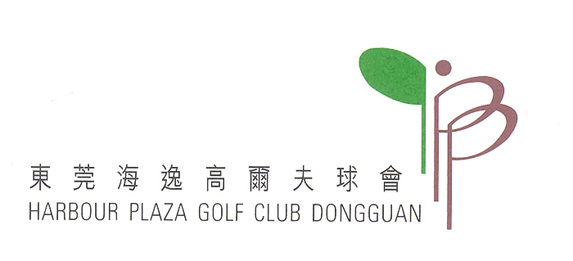

2013 Inter-Club Friendly Match
Dongguan Harbour Plaza Golf Club Vs Gen Zon Golf Club
Application Form

Venue: Gen Zon Golf Club, October 18th 2013 (Fri)
Dongguan Harbour Plaza Golf Club, TBC

Tee Time:
Golf Club & Course | Registration | Group photos, rules and prize explanation | Tee time | Prize presentation & dinner | Departure
Gen Zon Golf Club | 07:00 a.m.  Depart HPGC | 9:00 am. | 9:30 a.m. | 2:00 p.m. | 3:30 p.m
Dongguan Harbour Plaza Golf Club | 11:30 a.m. | 12:00 noon. | 12:30 a.m. | 5:00 p.m. | 6:00 p.m

Participants’ Eligibility : | Only members of these two golf clubs can participate and must play for both rounds.
Number allowed : | 22 players (including two staff) from each side, total 10 groups.
Format of the Game : | Best Ball.
Awards : | 1. Winning club; 2. Best Pairs, Nearest–the-Pin and Nearest-the middle-line for both rounds.
Honor : | The Winning club will keep the trophy for one year.
Transportation: | Each club will arrange their own transport.
Entry fee: | Only required to pay caddie & golf cart fees for each game. Meal charge(for both sides)for 18-October-2013 will be paid by members of Gen Zon Team whilst the meal for HPGC Course will be settled by members of HPGC

Member’s Name : | ________________ | Membership No : | ________________
Tel : | ________________ | E-Mail Address : | ________________
Handicap : | ________________ | Member’s Signature : | ________________

Please return your enrolment form to the Front Desk or Starter before the deadline.
Tel No: (0769) - 8581 8080. Fax No: (0769) - 8581 5921
Email: Dianasu@hpgclub.com

